**TENDER**

**FOR**

**[GHARBI MAIMANA KAN PROJECT]**

**PRE-QUALIFICATION QUESTIONNAIRE**

# GLOSSARY OF TERMS

The following words and expressions used within this PQQ shall have the following meanings:

|  |  |
| --- | --- |
| **Applicable Laws** | Means the applicable Mining law and other relevant applicable laws of Afghanistan. |
| **Association** | Means a prospective bidder in the form of a consortium or joint venture formed for the purpose of implementing Mining projects. |
| **Association Agreement** | Means an agreement of a consortium or joint venture for the joint implementation of a mining project.. |
| **Proposal** | Means the proposal to be submitted by the Qualified Bidder to the Ministry according to the Request for Proposals (RFP). |
| **Bidding Process** | Means the process initiated by the Ministry following the Tender Notice for the conclusion of a mining contract. |
| **Bid Document Fee** | Means, a specified amount to be paid by the Qualified Bidder to the Ministry prior to the receipt of the Request for Proposals (RFP). . |
| **Similar Experience** | Means the similar mining activities which has been already performed by the prospective bidder with similar technical and financial capabilities. |
| **IFRS** | Means the International Financial Reporting Standards adopted by the International Accounting Standard Board. |
| **PQQ** | Means pre-qualification questionnaire prepared by the Ministry for the purpose of preliminary evaluation of the prospective bidder's technical and financial capabilities. |
| **Prospective Bidder** | Means a legal entity (whether in the form of a consortium, joint venture, or sole entrepreneurship) interested to participate in the bidding process of mining contract. |
| **Qualified Bidder** | Means a Prospective Bidder who has fulfilled the requirements ascribed in the mining law & enforceable principles for participation in the bidding process of mining contract, in accordance with this PQQ. |
| **RFP (Request for Proposal)** | Means a document contain the requirements for submitting the request of proposal for the mining contract. |
| **Sponsor Entity** | Means, an entity that bears the cost of fulfilling the contractual obligations of the mining contract holder. |
| **Tender Notice** | Means a notice issued by the Ministry to initiate the bidding process for the specified mining area, published on the Ministry's website and other mass communication networks to notify the prospective bidders. |

The Mining law terms used in this PQQ shall carry the same meanings as defined in the Mining Law.

**PART 1**

**OVERVIEW OF THE PRE-QUALIFICATION Questionnaire EVALUATION**

# 1. INTRODUCTION

## A. Tender notice and description of the Mining area:

1. Ministry announce the designated mining areas through a tender notice on its website and other mass communication network, to identify prospective bidders for participation in the bidding process of mining contract.
2. The start and end dates for expressing interest in participating in the bidding process of mining contract are predicated in the tender notice.
3. The mining contract consists of the following two phases:

* **Exploration Phase**: It is a phase where the contract holder, after obtaining the exploration license based on terms and condition embedded in the contract, will commence the exploration activities in the area [Gharbi Maimana Kan Project]
* **Exploitation Phase**: It is a phase where the contract holder, after obtaining an exploitation license as per the results of the exploration report and feasibility studies, carry out mining and processing activities in accordance with exploitation plan, in the area [Gharbi Maimana Kan Project] specified in the license.

1. Details of the mining area, provided in Table Annex (1) of this questionnaire.

**B. The purpose of this PQQ:**

The purpose of this PQQ is to evaluate the eligibility, capability, and competencies of the prospective bidder (specifically their financial capability, technical expertise, and similar past experience) to participate in the bidding process of mining contract.

Timetable of PQQ Processing:

|  |  |
| --- | --- |
| 8 July 2025 | PQQ issuance Date |
| 6 August 2025 | PQQ submission Date |
| 11 August 2025 | PQQ Evaluation Date |
| 16 August 2025 | Date of notification to the prospective Bidders relating to the PQQ evaluation results. |

## C. Bid Document Fee:

Should the prospective bidders be found eligible, the qualified bidder must pay a non-refundable fee of 300,000 Afghanis for the RFP.

**D. Completion and submission of PQQ**

**1- Instructions for providing Responses:**

* All responses must be clear and precise.
* Responses should be typed in the computerized format provided.
* Answers must directly address the questions, avoiding unnecessary or irrelevant details.
* The questions must be answered in the template provided by the Ministry and to be submitted at specified deadline; late submissions will not be considered.
* Any alteration or additions to the template or contents of the PQQ by the bidder will result in automatic disqualification.
* Responses must be true and accurate; if found to be false, the bidder will be disqualified.

## C. Submission of PQQ Responses

1. The PQQ Response and supporting must be completed and provided in (i) English and (ii) either Pashto or Dari and submitted in hard 3 copies (one original and two copies) and soft copy to the Directorate of Large-Scale Mining Regulation.
2. All pages of the PQQ and supporting documents must be separately signed and stamped by the authorized representative of the prospective bidder.

## D. Changes to the submitted information

If any information submitted in a PQQ Response changes at any stage in the Bidding Process after the submission of their PQQ Response, the Prospective Bidder must promptly notify the Ministry in writing of any and all such changes.

# 2. General Rules relating to the Prequalification evaluation Process

1. Prospective bidders may request clarifications from the Ministry regarding the contents of this PQQ.
2. The Ministry may provide the clarifications to the Prospective bidder within 10 days prior to the deadline for submitting the PQQ.
3. Failure to provide the requested clarifications by the Ministry will not affect the processing of this PQQ.
4. If there is any ambiguity in the responses provided by the Prospective bidder, the Ministry may request further clarification from the bidder, provided that no changes are made to the contents of the PQQ.

## 3. Non-Disclosure of information

1. The Ministry is obliged to maintain the confidentiality of the information received concerning the prospective bidders in accordance with the relevant legislations.
2. The Ministry may share the provided information with relevant authorities to verify its accuracy and invalidity.
3. The received information will not be shared with any individual or authority except with the prior consent and agreement of the prospective bidders.

## 4. Notice to disqualified prospective Bidders

The ministry is obliged to notify the prospective bidders about the PQQ evaluation result, the disqualified bidders may within (2) working days after the announcement of PQQ result, ask the ministry to provide explanation of their disqualification.

**5. Change in the Timeline of the PQQ Evaluation Process**

The Ministry may change time to time the timeline for the processing of this PQQ if deemed necessary, except for the deadline for submitting the PQQ responses.

## 6. Suspension or Cancelation of the PQQ Evaluation Process

The Ministry may suspend or cancel the PQQ evaluation process if deemed necessary. In such instances, prospective bidders shall have no grounds for any complaints or claims against the Ministry.

**7. Copyright**

The copyright and publication rights of this PQQ are reserved by the Ministry, and no individual or entity has the right to reproduce or publish it.

**8. No Liability for cost**

The costs and expenses related to providing the PQQ responses are sole responsibility of the prospective bidders, and the Ministry shall not be held liable for any cost.

**9. Compliance with Legislations**

Prospective bidders are obliged to comply with the following:

1. No collusion with other bidders;
2. Compliance with relevant anti-corruption legislation;
3. No bribing of officials or employees of the Ministry to obtain information;
4. No interference in the process of the PQQ evaluation.

**Note**: Failure to comply with the above will result in disqualification of bidder.

**10. PQQ Evaluation Process**

The PQQ evaluation process will be conducted based on the methodology previously determined by the Ministry, adhering to the principles of equality, neutrality, and transparency.

**11. Selection of Qualified Bidders**

1. Prospective bidders who meet the predefined criteria based on the evaluation process will be considered qualified and will proceed to the next stage (bidding process).
2. Prospective bidders who do not meet the predefined criteria will not proceed to the next stage (bidding process).
3. The Ministry will notify Prospective bidders of the results of the PQQ evaluation process.

**PART 2**

**THE PQQ EVALUATION CRITERIA AND CAPABILITY STATEMENT**

# The prospective bidder shall, in compliance with the applicable Mining Law and enforced principles, demonstrate the required technical, financial, and similar past experience to undertake mining activities. This section establishes the specific criteria to evaluate and confirm the bidder's technical, financial, and relevant experience. The prospective bidder is required to submit information and supporting documents in accordance with the questions outlined in this section.

#### **1. GENERAL INFORMATION**

This section includes general information regarding the specifications, legal status, shareholders, and corporate structure of the prospective bidder. The prospective bidder is required to provide the necessary information by answering the questions below.

1. **Details of Prospective bidder:**

*Please provide the details of the prospective bidder as per the table below.*

|  |  |
| --- | --- |
| **Full legal Name of Company** |  |
| **Registration No.** |  |
| **Registration Date** |  |
| **Country in which the company was incorporated/registered** |  |
| **Address of principal place of business** |  |
| **Main office Address** |  |
| **Website** |  |
| **E-mail** |  |
| **Telephone** |  |

#### **Background and Experience of Prospective bidder**

Please provide a brief summary of the prospective bidder's background and experience in the table below.

|  |
| --- |
|  |

#### **Legal status**

Please indicate the current legal status of the Prospective Bidder by ticking the relevant box:

Limited liability company Consortium

Private limited company Partnership

Joint venture Sole proprietorship

Other *(please state in the box opposite)*

#### Please also indicate whether any government is a shareholder in the Prospective Bidder or any Group company and if so, the government of which country.

|  |
| --- |
|  |

#### **Organizational structure**

#### Please explain the organizational structure of the Prospective Bidder.

|  |
| --- |
|  |

#### **Details about Association Agreement**

#### Please answer this question in the form below and attach the relevant documents

|  |  |  |
| --- | --- | --- |
| **Is the Prospective Bidder an Association?** | **Yes/NO** | **If yes, please annex the Agreement to this PQQ** |

|  |  |
| --- | --- |
| **Percentage of shares** | **Name of Shareholders** |
|  |  |
|  |  |
|  |  |
|  |  |

#### **Further details about Association**

Please indicate in the table below which member of the Association will be responsible for which element(s) of the project.

|  |  |
| --- | --- |
| **Name of Association Member:** | **Responsibility** |
|  |  |
|  |  |
|  |  |

#### **Beneficial Ownership**

Please provide details of the Prospective Bidder’s Beneficial Ownership.

|  |
| --- |
|  |

#### **Conflicts of interest**

#### Is the owner, major owner, beneficial owner, or shareholder of the prospective bidder a government official or employee, or are government officials or employees directly or indirectly involved in the affairs of the prospective bidder? Yes / No.

If the answer is yes, please provide its details and specifications in the table below.

|  |
| --- |
|  |

#### **Shareholders of Prospective Bidders**

Please list details of prospective bidder’s Afghan or foreigner shareholders.

|  |  |  |  |
| --- | --- | --- | --- |
| **#** | **Shareholder Name** | **Nationality** | **Percentage of Share** |
| 1 |  |  |  |
| 2 |  |  |  |

#### **Details of Authorized Representative of the Bidder**

Please provide the details of Authorized Representative of the prospective Bidder below.

|  |  |
| --- | --- |
| **Name** |  |
| **Position** |  |
| **Address** |  |
| **Telephone** |  |

# 2. ELIGIBILITY REQUIREMENTS

#### Please answer the following questions with Yes/NO.

|  |  |  |
| --- | --- | --- |
| **#** | **Question** | **Answer (Yes or NO)** |
| 1 | Does the prospective bidder have a business license from the Ministry of Commerce and Industry? |  |
| 2 | Has the prospective bidder been declared bankrupt or insolvent? |  |
| 3 | Has the prospective bidder's license been revoked in the past three years due to violation laws? |  |
| 4 | Has the prospective bidder been convicted of bribery or corruption? |  |
| 5 | Has the major owner of the prospective bidder been convicted of crimes related to bribery or corruption within the past ten years? |  |
| 6 | Is the owner of the prospective bidder a government official or employee? |  |

1. Has the prospective bidder (or any member of the association, if applicable) been charged by the relevant authorities in Afghanistan for violating applicable laws? Yes/No.

If yes, please provide details below.

|  |
| --- |
|  |

1. Has the prospective bidder any outstanding financial obligations (debts) or legal disputes being proceed in courts with the Islamic Emirate of Afghanistan? Yes/No.

If yes, please provide details below.

|  |
| --- |
|  |

# 

# 3. FINANCIAL CAPABILITY

In accordance with the applicable Mining Law, to participate in the bidding process, the prospective bidder is required to submit specific financial information. This includes certified copies of audited financial statements, a statement of turnover, profit and loss, and cash flow for the last three years of operations, the most recent balance sheet, management accounts, and a statement outlining the cash flow for financing the project through internal sources. Alternatively, a letter of support from a bank or third party confirming their willingness to provide financing for the project should be included.

1. Please set out the following information for the Prospective Bidder for the last three financial years in line with IFRS:

|  |  |  |  |
| --- | --- | --- | --- |
| **Financial year ended:** |  |  |  |
| *Units* |  |  |  |
| *Reporting currency* |  |  |  |
| Revenue |  |  |  |
| Operating profit |  |  |  |
| Cash and cash equivalents |  |  |  |
| Fixed assets |  |  |  |
| Short and long term debt |  |  |  |
| Net assets (Total assets – Total Liability) |  |  |  |

1. Has the Prospective Bidder met all the terms of its banking facilities and loan agreements (if any) during the past 12 months? Please answer yes, no or not applicable, below.

|  |
| --- |
| **YES/NO/NOT APPLICABLE** (delete as applicable) |

If no, please explain below.

|  |
| --- |
|  |

1. Has the Prospective Bidder met all its obligations to pay its employees and creditors during the past 3 financial year? Please answer yes or no, below.

|  |
| --- |
| **YES/NO** (delete as applicable) |

If no, please explain below.

|  |
| --- |
|  |

1. Does the Prospective Bidder undertake to expend funds in exploration of the Project a minimum amount of USD [3,000,000] or equivalent? Please answer yes or no, below.

|  |
| --- |
| **YES/NO** |

#### Please provide the details of an active bank account, including the bank's name, address, and any relevant account information of the prospective bidder.

|  |  |
| --- | --- |
| **Bank Name:** |  |
| **Address:** |  |
| **Postcode:** |  |
| **Country:** |  |
| **Length of time relationship has existed:** |  |
| **Name of contact at the Bank:** |  |
| **Email address:** |  |
| **Telephone number:** |  |
| **Confirm that the nominated contact has been notified that they may be contacted by or on behalf of the Ministry, and that they has been authorised to provide information on the Prospective Bidder's financial capacity.** |  |

# 4 . TECHNICAL EXPERTISE AND EXPERIENCE

According to the applicable Mining Law, the prospective bidder is required to provide information regarding relevant technical expertise and experiences in order to participate in the bidding process. Therefore, the bidder is obligated to respond to the following questions:

1. **Execution of Similar Projects**

Has the prospective bidder conducted similar mining projects in exploration or exploitation phases for the past 10 years? Yes / No.

If yes, please provide the details in the table below.

|  |
| --- |
|  |

#### **Summary of technical expertise to conduct exploration**

#### Does the prospective bidder possess sufficient technical expertise to conduct exploration activities? Yes / No.

#### If yes, please provide a brief summary of the details in the table below.

|  |
| --- |
|  |

1. **Fulfilment of the commitments**

Has the prospective bidder fulfilled commitments related to social development, local benefits, environmental management, and health and safety during the exploration and exploitation phases of mining projects in the past ten years? Yes / No

If yes, please provide the details in the table below.

|  |
| --- |
|  |

#### **Implementation of Similar (Eligible) Projects – Exploration and Exploitation**

Has the prospective bidder previously conducted similar mining activities during the exploration and exploitation stages? Yes / No.

If yes, please provide the details according to the table below.

|  |  |
| --- | --- |
| **Name of Eligible Project/Contract** |  |
| **Employer/ Contracting Authority** |  |
| **Location of contracted area** |  |
| **Description of Contract** |  |
| **Date of commencement of the contract** |  |
| **Date of completion of the contract** |  |
| **Role of Prospective Bidder in the Execution of contract** |  |
| **Details of Referee for Eligible Project** |  |
| **Required attachments** |  |
| **Please attach the relevant supporting documents related to the contract and the Exploration and Exploitation activates with this PQQ.** | |

#### **Implementation of Social Development Plan in Similar Mining Activities- Exploration and Exploitation**

Has the prospective bidder previously implemented a social development plan in similar mining activities at the exploration and exploitation stages? Yes/No.

If yes, please provide details to the table below.

|  |  |
| --- | --- |
| **Details of the Mining Contract Under Which the Social Development Plan Was Implemented** | |
| **Employer/ Contracting Authority** |  |
| **Location of contracted area** |  |
| **Description of Contract** |  |
| **Date of commencement of the contract** |  |
| **Date of completion of the contract** |  |
| **Role of Prospective Bidder in the Execution of contract** |  |
| **Details of Referee for Eligible Project** |  |
| **Required attachments** |  |
| **Please attach the relevant supporting documents related to the contract and the implementation of your social development plan with this PQQ.** | |

#### **Implementation of Local content Plan in Similar Mining Activities:**

Has the prospective bidder implemented a Local content Plan in similar mining activities during the exploration and exploitation stages? Yes/No.

If yes, please provide details to the table below.

|  |  |
| --- | --- |
| **Details of the Mining Contract Under Which the Local content Plan Was Implemented** | |
| **Employer/ Contracting Authority** |  |
| **Location of contracted area** |  |
| **Description of Contract** |  |
| **Date of commencement of the contract** |  |
| **Date of completion of the contract** |  |
| **Role of Prospective Bidder in the Execution of contract** |  |
| **Details of Referee for Eligible Project** |  |
| **Required attachments** |  |
| **Please attach the relevant supporting documents related to the contract and the implementation of your Local content Plan with this PQQ.** | |

#### **Implementation of Environmental Management Plan in Similar Mining Activities:**

Has the prospective bidder previously implemented Environmental management plan in similar mining activities at the exploration and exploitation stages? Yes/No.

If yes, please provide details to the table below.

|  |  |
| --- | --- |
| **Details of the Mining Contract Under Which the Environmental Management Plan Was Implemented** | |
| **Employer/ Contracting Authority** |  |
| **Location of contracted area** |  |
| **Description of Contract** |  |
| **Date of commencement of the contract** |  |
| **Date of completion of the contract** |  |
| **Role of Prospective Bidder in the Execution of contract** |  |
| **Details of Referee for Eligible Project** |  |
| **Required attachments** |  |
| **Please attach the relevant supporting documents related to the contract and the implementation of your Environmental Management Plan with this PQQ.** | |

#### **Implementation of Health & Safety Plan in Similar Mining Activities:**

Has the prospective bidder previously implemented Health and Safety plan in similar mining activities at the exploration and exploitation stages? Yes/No.

If yes, please provide details to the table below.

|  |  |
| --- | --- |
| **Details of the Mining Contract Under Which the Health and Safety Plan Was Implemented** | |
| **Employer/ Contracting Authority** |  |
| **Location of contracted area** |  |
| **Description of Contract** |  |
| **Date of commencement of the contract** |  |
| **Date of completion of the contract** |  |
| **Role of Prospective Bidder in the Execution of contract** |  |
| **Details of Referee for Eligible Project** |  |
| **Required attachments** |  |
| **Please attach the relevant supporting documents related to the contract and the implementation of your Health and Safety Plan with this PQQ.** | |

**V. DECLARATION AND CERTIFICATION**

I hereby commit to providing all the requested information in this prequalification questionnaire accurately, truthfully, and without any deficiencies, exaggeration, deception, distortion, or misleading information.

In the event that any of the provided information is found to be incomplete, exaggerated, incorrect, or misleading, I accept that I will be disqualified from participating in the next stage (bidding process) and will bear the consequences. The Ministry will bear no liability in this matter.

|  |  |
| --- | --- |
| **Prospective Bidder’s name** |  |
| **Signed** |  |
| **Name of signatory** |  |
| **Position** |  |
| **Date** |  |

1. APPENDIX 1
2. 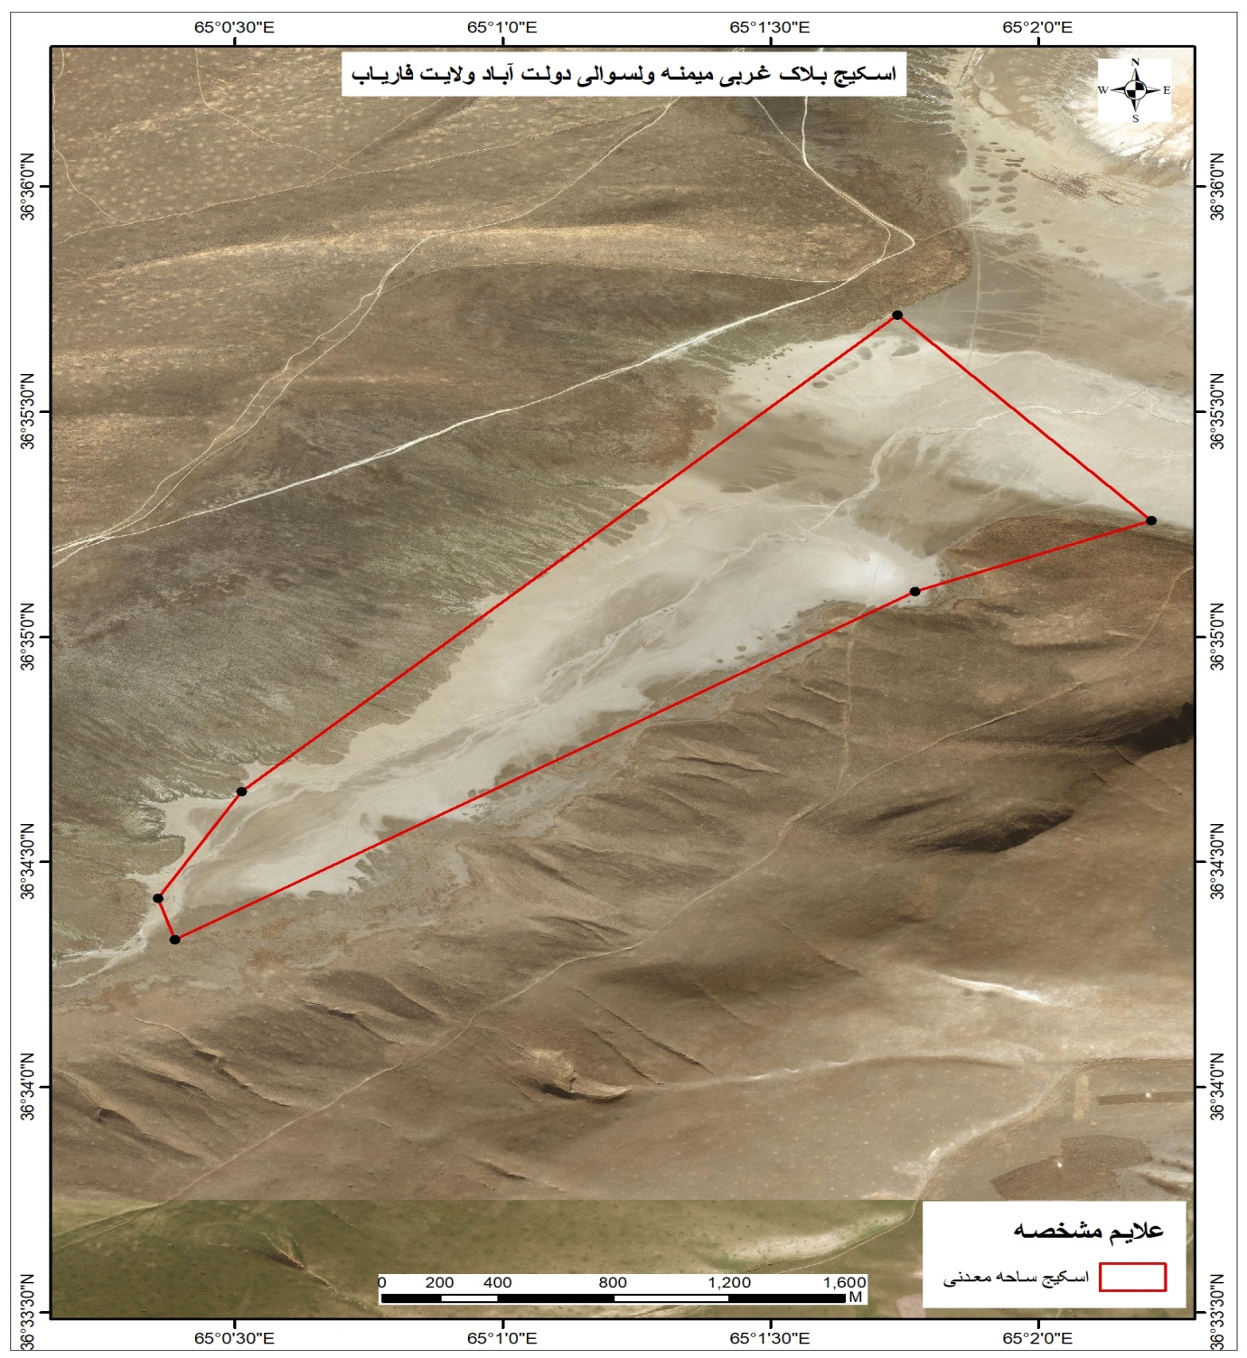 PROJECT Area

**APPENDIX 2**

**PROJECT DESCRIPTION**

|  |  |
| --- | --- |
| Subject | DETAILS |
| Type of Mineral | NaCl |
| Field Name | Shamal Zairat Kan Block |
| Location | This area is the northwestern end of the Salt Lake, which is located northeast of Dawlatabad and southwest of Andkhoy, 28 kilometers from the center of Dawlatabad district and 40 kilometers from the center of Andkhoy, among clay hills. |
| Geology | Continental salt lakes are formed in flat, bowl-shaped, flowless basins in hot, dry regions by the systematic evaporation of surface and groundwater that enters them. Considering this idea, the Maimane Salt Lake is of this type of continental basin and this salt basin is one of the contemporary salt basins. Considering some theories, it was believed that salt accumulated in the flowless basins of the desert as a result of the washing of their crystals by groundwater. In general, it is inferred that the Maimane and Andkhoi salt mines are classic sedimentary formations that were formed in past geological periods in hot, dry climates mainly in the process of evaporation of seawater in the form of separate ghadirs. The source of nutrition in the Maymaneh salt mine is mostly springs that penetrate from underground waters to the surface. In the spring and summer, the lake water level rises, and in late summer, the water evaporates and salt is deposited in layers of 10cm to 20cm on the surface, which is exploited. In addition, thin layers of mud and soil that have deposited under the thin layers of salt are excavated again after the first layers of salt are removed, and the layer below it is extracted in the form of gravel salt, the salt layer of which reaches up to 20 cm.  The rocks and sediments that can be observed near the salt lake consist of carbonate clay or clay, wind deposits, loess, and alluvial gravel. |
| Previous studies | Geological mapping at a scale of 1:500,000 by Russian and Afghan specialists. Available research materials related to the area are in Russian. |
| Area and coordinates | The area is (1.98917) square kilometers:   |  |  |  |  |  |  | | --- | --- | --- | --- | --- | --- | | **E** | | | **N** | | | | Grades | Minutes | Second | Grades | Minutes | Second | | 65 | 0 | 21.3 | 36 | 34 | 25.2 | | 65 | 0 | 30.7 | 36 | 34 | 39.4 | | 65 | 1 | 44.2 | 36 | 35 | 42.9 | | 65 | 0 | 23.2 | 36 | 34 | 19.7 | | 65 | 0 | 23.2 | 36 | 34 | 19.7 | | 65 | 1 | 46.2 | 36 | 35 | 6.1 | | 65 | 2 | 12.7 | 36 | 35 | 15.5 | |
| Social and environmental information | This area is located in a plain area, there are no surface water flows, and there are no residential houses in the area. Only temporary water flows flow into the salt pans of this area due to seasonal floods. |
| Infrastructure | There are no infrastructure projects around the area, and the road used for transporting salt and for the movement of companies involved in the mining area is in very poor condition and needs serious attention from the relevant authorities. |
| conclusion | According to studies conducted in the area, the salt in this area was interesting, but due to the presence of thick sediments, the salt-water springs have been closed and partially dried up. If cleaning is done, it will be possible to strengthen the springs for salt extraction. |